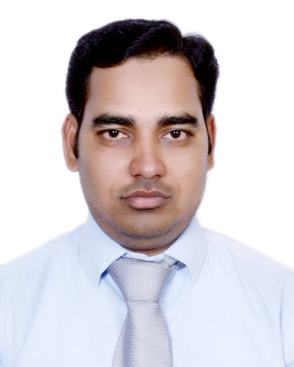

Curriculum Vitae

Dr. MD NASIR ALI(PT)  Personal Summary  A highly motivated, confident individual with exceptional multi-tasking and organisational skills. Able to communicate effectively and sensitively with patients and carers to maximise the rehabilitation of patients and to ensure understanding of often complex clinical issues impacting on recovery. Excellent client facing skills and the ability to work closely with other health care professionals to assess a patients needs and devise suitable treatment plans for them.  Personal Information  Father's Name: MD Waris Ali  Mothers Name: RehanaKatoon  Date of Birth:January 17, 1987  Sex: Male  Nationality: Indian  Marital Status: Single  Languages: English, Urdu,Hindi  Correspondence Address:  Flat no. 140, 9th floor, Al dahir st. opp. Al wahda Mall  Airport Road, Abu Dhabi-8550  UAE  Permanent Address:  Alam tola, w.no-23  Forbesganj Araria  Bihar (India) 854318  Contact:  mdnasiralijmi@gmail.com  +971562571302/ +971563770670(Mob.) | Career Objective  To be associated with a firm, that provides career development opportunities and contributes in its progress through my knowledge and skills, which would go a long way in building bright and challenging career in the field of physiotherapy and rehabilitation sciences.  Area of interest  Musculoskeletal andOrthopaedics physiotherapy, Stroke management, Sports injuries, Patient care, Neurological conditions, Cardiology, Ante natal and post natal therapeutic exercises, Community Medicine.  Academic Profile  - BPTwith first division,from Centre for Physiotherapy and Rehabilitation Sciences, JamiaMilliaIslamia, New Delhi, India.  - 6 Months Internship from St. Stephens’s hospital, Delhi, India.  - Intermediatewith first division from B.I.E.C, Patna.  - High school examination with first division fromB.S.E.B, Patna.  Academic acheivements& Membership  - HAAD LICENSE PASSED ON 10/11/16.  - Member of Foundation of Rajdhani Clinical Physiotherapist (358).  - LIFE MEMBER OF INDIAN ASSOCIATION OF PHYSIOTHERAPIST.

ProfessionalEXPERIENCE
- From 3rd January 2014 to 31st Oct 2016, worked as a physiotherapist in Park hospital, Gurgaon (India)
    - Managed physiotherapeutic treatment of both outpatients and inpatients in the hospital, give comprehensive assessment and treatment to the highest standard and keep records of the patient information.

- From 1stFebruary 2013 to 31st December 2013, worked as a physiotherapist in Bapu Nature cure hospital, Delhi (India).

    - Provided physiotherapeutic treatment for outpatients. Responsible for managing a clinical caseload, providing physiotherapy assessment and treatment to the highest standard.

- Sixth Months Compulsory Internship from,St. Stephens’s hospital, Tis Hazari, Delhi (India).

IN BPT: 2 month each hospital compulsory training 4 hr. a day.
- Centre for Physiotherapy and Rehabilitation Sciences,JamiaMilliaIslamia, New Delhi-110025
- Ansari Health Centre, JamiaMilliaIslamia, New Delhi-25
- Leonard Cheshire Home,Okhla New Delhi-110025
- Guru Harikishan Hospital GurdwaraBala Sahib, Ring Road, New Delhi-110025
- CharakPalika N.D.M.C.Hospital Motibagh, New Delhi
- Centre for Early childhood Development and Research, New Delhi
- St. Stephens Hospital, Tis Hazari, Delhi
- Bara Hindu Rao hospital, civil lines Delhi
- ESI hospital okhla New Delhi.
- Safdarjung Hospital, Sports injury Centre, New Delhi(India).

Professional Skills
- Comprehensive problem solving abilities
- Excellent written and verbal communication skills
- Willingness to learn team facilitator and hard worker
- Able to manage escalations, issues and risks.
- Experience of dealing with emotional and stressful situations.
- Can motivate others through effective communication skills.
- Able to deal with hostility in the form of verbal and physical aggression.
- Ability to work independently in busy environment.
- Highly developed dexterity, co-ordination and palpation skills for assessment.
- Fully aware of fire, health & safety and other departmental policies.
- Flexibility to work weekends on rotational basis

desertation work
(As a part of Bachelor of Physiotherapy degree)

“Proprioception assessment in Anterior cruciate ligament reconstructed patient”

Conferences AND WORKSHOP attended
- Attended hands on workshop on Kaltenborn principles of manual therapy of spine and extremities (Basic + advanced) by APTE, at CPRS, JamiaMilliaIslamia
- 8 hours of hands on workshop on Mulligan concept of mobilization of spine and extremities.
- Workshop on ‘Kinanthropometery’ New Delhi.
- Participated in symposium “The Young Athlete” held on 5th October 2013 at VIMHANS, New Delhi.
- Participated in hands on workshop on “Exercise Testing and Prescription” at CPRS, JamiaMilliaIslamia, by Dr. Fiddy Davis.
- Attended workshop on “Bands, balls and Balance” at JamiaMilliaIslamia conducted by Dr. Deepak kumar, Thera Band Academy
- One day workshop on PNF Techniques, by Dr. Harpreet Singh, 2015 held at JamiaMIlliaIslamia
- National Symposium on Healthy Ageing, New Delhi.
- Symposium on Cardiopulmonary Rehabilitation, New Delhi.
- 2nd International congress on Gerontology and Geriatric Medicine(25-29 Feb 2012 at AIIMS & UCMS, NEW DELHI)
- Workshop on Therapeutic Evaluation & Rehabilitation by Isokinetic Dynamometry at ManavRachna International University, Faridabad.
- Workshop on Life Style Modification of Leprosy cured patient at TLM Shahdra New Delhi.
- Workshop on Orthotic and Prosthesis devices at Indian Spinal Injury Center, New Delhi.
- 2 Days Neuro Physical Therapy Workshop 2012, Medanta-The medicity (India)
- Early Intervention in Child at KASTURBA MEDICAL COLLEGE, Manglore in December 2011.

DECLARATION

I hereby declare that the given above information are true to the best of my knowledge and belief and can be supported with reliable documents when needed.

Place:
Date: -----/------ 2016 (MD. NASIR ALI)

